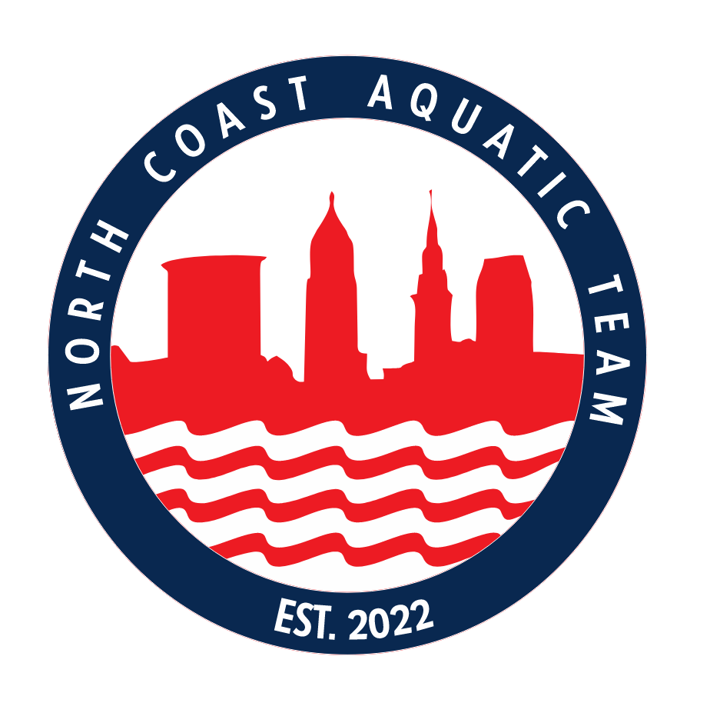 | NCAT FALL BREAKOUT  11/16/2024  Held under the sanction of USA Swimming  Sanction/Approved #LE 25020 SS | Hosted by  The North Coast Aquatic Team

Location: | Solon High School  33600 Inwood Dr., Solon, OH 44139
Facility: | 25 yard/8 lanes, electronic timing with 8 lane board, locker rooms, elevated spectator area. Continuous warm-up and warm-down will be available in the diving well.  The competition course has not been certified in accordance with 104.2.2C (4). The depth of the pool at the start end is 6 feet, 0 inches. The depth at the turn end is 4 feet, 0 inches.
Meet Director: | Eric Peterson  Eric.peterson@ncatswim.com  (216) 295-4163
Meet Referee: | Dave Brown
Meet Admin: | Eric Peterson – Meet Director
Entry Chair: | Eric Peterson  Eric.peterson@ncatswim.com  (216) 295-4163
Disclaimer: | In granting this sanction it is understood and agreed that USA Swimming shall be free from any liabilities or claims for damages arising by reason of injuries to anyone during the conduct of the event.
Meet Type: | Please see event listings. Swimmers must be slower than NAG BB times as of the entry deadline. If the swimmer has no time, please include a time even if it is a practice time. NT will NOT be accepted.
Entry Deadline | ENTRY DEADLINE:  Entries, electronic or otherwise, will not be accepted before Monday, October 14, 2024 at 9:00 PM. Entries will be taken on a first come first serve basis. It is suggested that you sync your computer time with the official U.S. time clock found at http://www.time.gov/ or www.time.is prior to submitting your entries. Deadline for submission of Hy-Tek/hard copy entries is November 6, 2024. The meet may close before the deadline if the sessions reach the maximum length so mail early. Those who get closed out will be notified by email as soon as the session closes.  Email entries to: ncatmeetentries@gmail.com Mail hard copy & payment to: North Coast Aquatic Team, PO Box 201009, Shaker Heights, OH 44120
# and Description of Session: | Session 1 – 11 & Overs- Warm-up begin 7:30 am, Meet start 8:35 am. Events are timed finals.  Session 2 – 10 & Under- Warm-ups will begin 15 minutes after the conclusion of the AM session. Estimated timeline will be posted by Wednesday, November 13, 2024. Events are timed finals.  The finalized warm up plan may be found at www.lakeerieswimming.com by Wednesday 13, 2024 of the meet start day.
Medical Supervision available to athletes | Lifeguards will be on duty throughout the meet. Please report any medical issues or concerns to the MEET SAFETY DIRECTOR.

Organization Regulations/Waivers
USA Swimming Rules | - At a sanctioned competitive event, all USA Swimming athletes must be under the supervision of a USA Swimming member coach. Arrangements for coach supervision must be made in advance of the meet.  - Any swimmer entered in the meet must be certified by a USA Swimming member-coach as being proficient in performing a racing start or must start each race from within the water without the use of the backstroke ledge. When unaccompanied by a member-coach, it is the responsibility of the swimmer or the swimmer’s legal guardian to ensure compliance with this requirement.  - The use of audio or visual recording devices, including a cell phone, is not permitted in changing areas, rest rooms or locker rooms.  - Use of cameras, cell phones or any other recording device is not permitted immediately behind the starting blocks at either end of the racing course(s) during race starts, competition and warm-ups. Please refer to the Safe Sport section of the LESI Swimming, Inc. policies and procedures for further information regarding the use of visual recording devices.  - Deck changes are prohibited.  - Operation of a drone, or any other flying apparatus, is prohibited over the venue (pools, athlete/coach areas, spectator areas and open ceiling locker rooms) any time athletes, coaches, officials and/or spectators are present.  - Flash photography is not permitted at the start of any race.  - All applicable adults participating in or associated with this meet acknowledge that they are subject to the provisions of the USA Swimming Minor Athlete Abuse Prevention Policy (MAAPP) and that they understand that compliance with the MAAPP policy is a condition of participation in the conduct of this competition.
Technical Suit Ban | Per USA Swimming Rule 102.8.1F, 12 & Under athletes may not compete in Technical Suits at this meet.  A Technical Suit is one that has the following components:  - Any male or female suit with bonded or taped seams regardless of fabric or silhouette; or  - Any male or female suit with woven fabric extending to the knee or mid-thigh regardless of the seam type.
Racing Starts | Any swimmer entered in the meet must be certified by a USA Swimming member coach as being proficient in performing a racing start or must start each race from within the water without the use of the backstroke ledge. When unaccompanied by a member-coach, it is the responsibility of the swimmer or the swimmer’s legal guardian to ensure compliance with this requirement.
Ohio State Laws that are applicable to Lake Erie Swimming sanctioned events | - Ohio’s Return to Play Law (ORC 3313.539 and ORC 3314.03) requires that coaches and referees either (1) complete a free online training once every three (3) years in recognizing the symptoms of concussion.  - There will be the required number of certified lifeguard(s) on duty at all times at this meet per Ohio Administrative Code 3701-31-04-E-4.
Safe Sport 360 | - The U.S. Center for Safe Sport program is a comprehensive abuse prevention program dedicated to creating a healthy and positive environment free from abuse for all its members. Components of the program include, but are not limited to, providing education and training, enforcing policies (such as the Minor Athlete Abuse Prevention Policy), rules and best practice guidelines, promoting healthy boundaries and mandatory reporting of violations.  - The Minor Athlete Abuse Prevention Policy (MAAPP) prohibits Applicable Adults (as defined) from having one-on-one interactions with minor athletes which are not within an observable and interruptible distance from another adult. Applicable Adults are required to abide by this policy in full during this meet.  - Pursuant to USA Swimming Rules and Regulations and federal law, it is every member’s responsibility to immediately (i.e., within 24 hours) report any incident of child abuse, including physical or sexual abuse, to law enforcement and the U.S. Center for SafeSport. Reporting must occur when an individual has firsthand knowledge of misconduct or where specific and credible information has been received from a victim or knowledgeable third party. A report to the U.S. Center for SafeSport may be made via telephone at 833-5US-SAFE (833-587-7233) or online at www.uscenterforsafesport.org/report-a-concern. Various state laws may also require reporting to law enforcement or to a designated child protection agency.  - All athletes aged 18 and older must complete Athlete Protection Training in order to be a USA Swimming registered member in good standing. Any athlete who turns 18 on or after the first day of the start of competition, who has not completed Athlete Protection Training by the first day of competition, will be prohibited from participating in the competition until such time as all membership requirements are completed. Times achieved by an athlete who turns age 18 on or after the first day of competition, who competes in this USA Swimming sanctioned event without completing this membership requirement, will NOT count for qualification or recognition. This includes participation as a member of a relay.  - All applicable adults participating in or associated with this meet, acknowledge that they are subject to the provisions of the USA Swimming Minor Athlete Abuse Prevention Policy ("MAAPP"), and that they understand that compliance with the MAAPP policy is a condition of participation in the conduct of this competition.  - Operation of a drone, or any other flying apparatus, is prohibited over the venue (pools, athlete/coach areas, spectator areas and open ceiling locker rooms) any time athletes, coaches, officials, and/or spectators are present  - For information on how to report other alleged violations, including without limitation, the USA Swimming Code of Conduct, and the Minor Athlete Abuse Prevention Policy, please visit www.usaswimming.org/report
Waiver/Release | - In granting this sanction, it is understood and agreed that USA Swimming shall be free from any liabilities or claims for damages arising by reason of injuries to anyone during the conduct of the event.  - By entering this meet, you are granting permission for the names of any or all of your team’s swimmers to be published on the internet in the form of Psych Sheets, Meet Results, or any other documents associated with the running of this meet.  - All participants agree to be filmed and photographed by the host club approved photographer(s) and videographers and to allow the right to use names and pictures before, during, or after the meet such as in public psych sheets, heat sheets, and results or featured on the host club or LEI website or social media or in public broadcast of the event via television or webcast. Parents and guardians of minor swimmers who do not wish their swimmers to participate in interviews or have individual pictures featured on any media should inform their team’s head coach and the Meet Director prior to the meet.  - RISK OF EXPOSURE TO COVID 19: An inherent risk of exposure to COVIC-19 exists in any public place where people are present. COVID-19 is an extremely contagious disease that can lead to severe illness and death. According to the Centers for Disease Control and Prevention, senior citizens and individuals with underlying medical conditions are especially vulnerable. USA Swimming, Inc. cannot prevent you (or your children) from becoming exposed to, contracting, or spreading COVID-19 while participating in USA Swimming sanctioned events. It is not possible to prevent against the presence of the disease. Therefore, if you choose to participate in a USA Swimming sanctioned event, you may be exposing yourself to and/for yourself to and/for increasing your risk of contracting or spreading COVID-19.
Code of Conduct | - Any individual who exhibits a behavior of a threatening, abusive, or derogatory manner toward an official or member of the meet staff is subject to immediate removal and further expulsion from the meet. Coaches will be notified of the actions of their respective teams.  - Good sportsmanship is expected at all times. Bullying or taunting, foul language or derogatory behavior will not be tolerated and will be subject to immediate removal. All volunteers, spectators, coaches, officials and meet staff are expected to be respectful of others.  - The LESI Swimming Code of Conduct governs this meet. The purpose of the Zero-Tolerance Code of Conduct Policy is to establish consistent expectations across the LSC in the best interest of our Athletes and Sport. LESI Swimming is committed to creating a safe and fair environment for all of its athlete members. This policy is to be used as a guide to promote a positive environment and good sportsmanship at meets and events conducted in the geographical boundary of LESI Swimming. The complete LESI Swimming Code of Conduct can be reviewed on the LESI Swimming website under Governance> LESI Policy & Procedures Manual.

Entering the Meet and Competition Information
Eligibility:  Applies only to USA meet | - All meet contestants must be a member in good standing per Article 302..  - All contestants must be verified USA Swimming members. Deck Entry at a meet must show electronic athlete membership or a club coach must sign the Deck Entry Form.  - Membership verification deadline is 5 PM EST two (2) business days prior to the first day of the meet Unverified swimmers will be scratched from the meet after that deadline. There will be no refunds for unverified swimmers scratched from the meet.  - All adult athletes must hold current Athlete Protection Training certification. All adults participating in or associated with this meet, acknowledge that they are subject to the provisions of the USA Swimming Minor Athlete Abuse Prevention Policy (MAAPP), and that they understand that compliance with MAAPP is a condition of participation in the conduct of this competition.  - Age on the first day of the meet will determine age for the entire meet
Swimmers with a Disability: | - Entry Procedures:  - Enter the USA-S swimmers with a disability electronically with your team entries.  - Email the Meet Accommodation / Modification Form included in this meet information to the entry chair.
Entry Limits  Entry Fees: | - Swimmers may swim a maximum of [4] individual events per day.  - $35 surcharge per swimmer, includes admission for (2), up to 4 events entry per swimmer, & $3 LESI surcharge.  - There is a $2.00/swimmer handling fee for entries not furnished in an electronic file.
Entry Procedures: | - Deadline for receipt of entries is November 6, 2024  - Entries must be submitted in [SCY / LCM / SCM] using an electronic meet entry software (Hy-Tek/Team Unify).  - Send entries to Eric Peterson, ncatmeetentries@gmail.com. Swimmers may enter up to 4 events/day, The Meet Director reserves the right to limit entries, if necessary, to manage the timeline and number of competitors and spectators at each session.
Entry Eligibility | - Swimmers must be current athlete members of USA Swimming and Lake Erie Swimming and have met the time standard requirements. Coaches must be current coach members of USA Swimming and must check in on each day of the meet. All coaches must display the deck pass (wristband) issued by the meet host.
Qualifying Times | - Please see event listings. Swimmers must be equal to or faster than or slower than the qualifying time listed as of the entry deadline. NT will not be accepted; if the swimmer has no time, please provide an estimate
Proof of Time | This is a SLOWER THAN MEET:  Swimmers may not compete in an event in which they are faster than the listed time standard as of the meet entry deadline. Entry times are investigated after the meet if a protest is filed.
Warm-up and Safety Guidelines: | - Lake Erie Swimming safety guidelines and warm-up procedures will be in effect at all times.  - Coaches must maintain contact with their swimmers during warm-up and throughout the meet. Warmups AM (2) 30 minute sessions, PM may be 1 (40) minute session and may be split if the average number of swimmers per lane is scheduled to exceed USA Swimming’s recommended number of athletes per lane. There should be only two swimmers behind the blocks during starts.
Swimmers with a Disability | Qualifying times for 50-yard/meter events will be waived for swimmers with a disability. Swimmers with a disability may enter an event (such as the 100 free) and swim it with a longer yardage event (such as the 200 free) provided his/her time for the lesser yardage event (100 free) is equal to or faster than the listed qualifying time for the longer yardage event (200 free). Entries for swimmers with a disability should be handled in the following manner: (1) enter the swimmer in the Hy-Tek database (or on the regular entry form); (2) list in the email accompanying the Hy-Tek entry file (or on a separate sheet of paper) the name of the swimmer, the stroke(s)/distance(s) s/he wishes to swim, the entry times, the day/session s/he wishes to swim the event(s), and the manner in which s/he prefers to be seeded (with a longer distance or with a different age group); and (3) provide any information about special accommodations needed by the swimmer. The final determination of seeding will be made by the Meet Referee after consultation with the swimmer and his/her coach.
Team Supervision | Teams who are entering swimmers but will not have a coach at the meet should arrange ahead of time for another coach to supervise their athletes. Swimmers without coach supervision must contact the Meet Director or Meet Referee to be assigned to a coach on deck.
Competition Guidelines: | - THIS MEET IS PRE-SEEDED.  - Events seeded on the deck shall be closed for seeding no earlier than forty-five (45) minutes prior to the start of the session. Hosts may provide alternate methods of check-in (such as email, phone, and fax) for swimmers who do not plan to arrive before the scratch deadline.
Deck Entries | Swimmer must show proof of membership electronically or coach signs a deck entry form. Deck entries may be accepted up to 45 minutes prior to the start of the session. $15 per individual event plue $3.00 LESI surcharge. The final decision to accept deck entries will be published after the meet entry deadline has passed.
Awards: | Individual Events:  12 & Unders- 1st – 6th place ribbons per event.
General: | Heat Sheets will be posted at the meet in the lobby for spectators and at various locations on the pool deck for swimmers. The meet will also be posted on MeetMobile.

SCRATCH RULE
1) Each swimmer/relay team shall be aware of the meet starting time and shall report to the proper meet authorities promptly upon call.
2) Pre-Seeded Event: Each swimmer/relay team shall report promptly to the Clerk of Course or starting blocks prior to the race in which the swimmer/relay team is entered. Any swimmer/relay team not reporting for or competing shall not be penalized. Teams that enter multiple swimmers and subsequently fail to notify the meet host prior to the seeding that multiple swimmers they entered do not intend to compete may be fined $25 per swimmer per day, at the discretion of the Meet Referee.
3) Events Seeded on the Deck
a) Any swimmer who has checked in for an individual event 400 yards/meters or longer must swim in the event unless the swimmer notifies the Administrative Official before the seeding of the event has begun that the swimmer wishes to scratch; failure to scratch prior to seeding and not swimming the event will result in a fine of $25.00 to the swimmer’s club or to the unattached swimmer, except as noted in “Exceptions for Failure to Compete'' (below). A declared false start or deliberate delay of the meet in events 400 yards/meters or longer is not permitted and will be regarded as a failure to compete.
b) Any agent of a team (coach, parent, swimmer, etc) who check in swimmers for events when those swimmers are not present at the meet may cause a fine of $25.00 per swimmer per day to be levied against the team, as the discretion of the Meet Referee.
c) Events seeded on the deck and swum as a timed final with one or more heats swimming with finals shall provide the swimmers the opportunity to indicate their desire to swim only during the preliminary session by indicating this desire by placing a “P” next to their name on the check-in sheet. Any swimmer failing to indicate this desire who does not compete during the finals session shall be subject to a fine of $25.00, except as noted in “Exceptions for Failure to Compete “ (below).
4) Scratching from Finals
a) Any swimmer qualifying for a bonus, consolation, or championship final race in an individual event who fails to compete in said final race shall be barred from further competition for the remainder of the meet, except as noted below in “Exceptions for Failure to Compete ''. If such failure to compete occurs on the swimmer’s last day of the meet, the swimmer’s club shall be fined $25.00 by LESI. If the swimmer is not a member of a USA Swimming member club, the swimmer shall be fined $25.00. A declared false start or deliberate delay of the meet is not permitted and will be regarded as a failure to compete.
b) In the event of withdrawal or barring a swimmer from competition, the Referee shall fill the bonus, consolation, or championship final, when possible, with the next qualified swimmer(s). First and second alternates shall be announced along with final qualifiers. These alternates shall not be penalized if unavailable to compete at finals.
c) When consolation finals have not yet been swum and a barring or withdrawal is known to the Referee, the Referee shall re-seed the consolation final and the final, if necessary, to insert the alternate(s) in the appropriate lane(s), filling all lanes in the final.
d) If a consolation final has already been contested, the final shall be swum without reseeding for the empty lane(s). 5) Exceptions for Failure to Compete: No penalty shall apply for failure to withdraw or compete in an individual event if a) The Referee is notified in the event of illness or injury and accepts the proof thereof.
b) A swimmer qualifying for a bonus or consolation final or final race following preliminaries notifies the Referee or designee within 30 minutes after the announcement of the qualifiers for that race that the swimmer may not intend to compete. The swimmer must declare within 30 minutes following the swimmer’s last individual preliminary event a final intention to scratch or swim.
c) It is determined by the Referee that failure to compete is caused by circumstances beyond the control of the swimmer.

Summary of Fees/Release Form
The North Coast Aquatic Team Fall Breakout 24’

Team Name
Club Representative
Club Rep Email
(for questions about entries)
Coach Attending
Coach Phone
Coach Email

Item | Total # | Cost per | Total
Individual Entries (exclude Outreach) |  | $35.00 per swimmer
Relay Entries |  | n/a | 0.00
LESI Swimmer Surcharge (exclude Outreach) |  | Included
Host Team Facility Surcharge (exclude Outreach) |  | N/A | 0.00
Total Fees Due

Waiver, Acknowledgement and Liability Release:
I, the undersigned coach, or team representative, verify that all the swimmers listed on the enclosed entry and coaches attending the meet are current USA Swimming members IN GOOD STANDING. I acknowledge that I am familiar with the Safety Rules of USA Swimming, Inc. and Ohio Swimming, Inc. regarding warm-up procedures and meet safety guidelines, and that I shall be responsible for the compliance of my swimmers with those rules during this meet. The North Coast Aquatic Team, Solon, Ohio Swimming, Inc., and USA Swimming, Inc., their agents, employees, and coaches shall be held free and harmless from any and all liabilities or claims for damages arising by reason of illness or injury to anyone during the conduct of this meet. I also acknowledge that by entering this meet, I am granting permission for the names of any or all of my team’s swimmers to be published on the internet in the form of Psych Sheets, Meet Results, or any other documents associated with the running of this meet.

Signature (Coach or Club Representative) Club Title (Coach etc)

Name of Club Date
Send this form with check to: The North Coast Aquatic Team, PO Box 201009, Shaker Heights, Oh 44120. Checks made payable to: North Coast Aquatic Team

Lake Erie Swimming Meet Accommodation Form for Swimmer with a Disability

Meet Name:
Date of Meet:
Team:
Swimmer’s Name:
Swimmer’s Ability Grouping (P1, P2, P3)
Coach’s Name:
Coach Cell:

What, if any, accommodations are needed for the swimmer (include access to facility) up to the time they arrive at the starting block?

What modification of the technical rules per Article 105 (in accordance with 105.1.2) are needed for the swimmer with a disability for this event?

Event # | Description | Modification(s) Per Article 105

Please send a copy of this for to both the meet entry chair and Referee for the Meet.

NCAT Fall Breakout
Saturday, November 16, 2024
Hosted by The North Coast Aquatic Team

AM SESSION (11 AND OVER GIRLS AND BOYS)

Warm-ups start at 7:30 am; Warm-ups will be 45 minutes and will be 30 minutes if split. Events may be combined depending on the number of entries. Finalized warm-ups plan will be posted by Wednesday, November 13, 2024

Girls  Event# | Qualifying Time  Must be slower than | Age Group/Stroke | Qualifying Time  Must be slower than | Boys  Event #
1 | 2:28.99 | 11 – 12 200 Free | 2:23.49 | 2
3 | 13 -14: 2:21.29  15 & O: 2:18.69 | 13 & O 200 Free | 13-14: 2:12.79  15 & O: 2:06.79 | 4
5 | 39.99 | 11 – 12 50 Breast | 39.49 | 6
7 | 13-14: 1:21.69  15 & O: 1:19.69 | 13 & O 100 Breast | 13-14: 1:15.49  15 & O: 1:11.09 | 8
9 | 35.39 | 11 – 12 50 Back | 34.99 | 10
11 | 13-14: 2:34.89  15 & O: 2:31.39 | 13 & Over 200 Back | 13-14: 2:25.09  15 & O: 2:17.49 | 12
13 | 1:08.29 | 11 – 12 100 Free | 1:05.89 | 14
15 | 13-14: 1:05.49  15 & O: 1:03.99 | 13 & O 100 Free | 13-14: 1:00.89  15 & O: 57.89 | 16
17 | 33.89 | 11 – 12 50 Fly | 34.19 | 18
19 | 13-14: 1:10.89  15 & O: 1:09.39 | 13 & Over 100 Fly | 13-14: 1:06.09  15 & O: 1:02.69 | 20
21 | 1:18.09 | 11 – 12 100 Back | 1:15.69 | 22
23 | 13-14: 1:11.19  15 & O: 1:09.39 | 13& O 100 Back | 13-14: 1:06.39  15 & O: 1:03.19 | 24
25 | 31.29 | 11 – 12 50 Free | 30.29 | 26
27 | 13-14: 30.19  15 & O: 29.49 | 13 & O 50 Free | 13-14: 27.79  15& O: 26.39 | 28
29 | 1:18.09 | 11 – 12 100 IM | 1:14.99 | 30
31 | 13-14: 2:37.59  15 & O: 2:34.89 | 13 & O 200 IM | 13-14: 2:28.49  15 & O: 2:20.89 | 32

Awards for 11-12 only.

NCAT Fall Breakout
Saturday, November 16, 2024
Hosted by The North Coast Aquatic Team

PM SESSION (10 AND UNDER GIRLS AND BOYS)

Events may be combined depending on number of entries
45 minute Warm-ups will start 15 Minutes after the conclusion of the AM Session
Finalized warm-ups plan will be posted by Wednesday, November 13, 2024

Girls  Event# | Qualifying Time  Must be slower than | Age Group/Stroke | Qualifying Time  Must be slower than | Boys  Event #
33 | 47.49 | 10 & U 50 Breast | 46.59 | 34
35 | 1:30.69 | 10 & U 100 Back | 1:29.29 | 36
37 | 41.79 | 10 & U 50 Fly | 40.49 | 38
39 | 1:19.99 | 10 & U 100 Free | 1:18.79 | 40
41 | 41.89 | 10 & U 50 Back | 42.29 | 42
43 | 1:31.69 | 10 & U 100 IM | 1:28.89 | 44
45 | 35.19 | 10 & U 50 Free | 34.49 | 46

Will be awarded 8 & Under, 9 - 10

